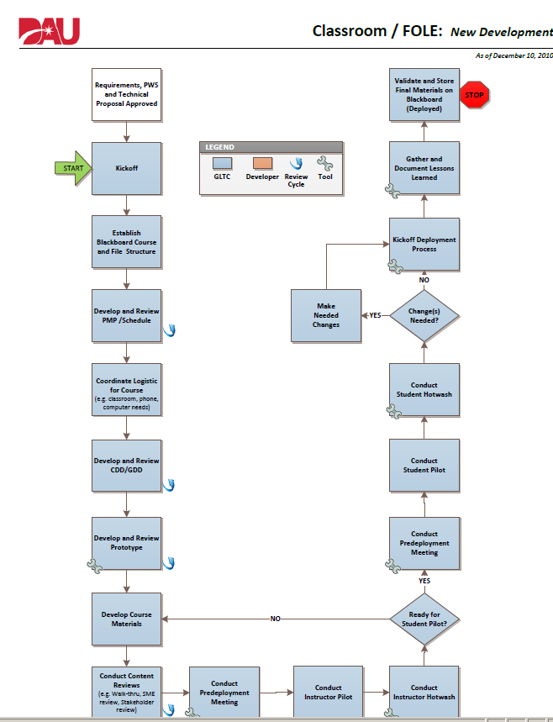

Debra’s comments

Admittedly, this graphic is heavy on administrative-type tasks, but ADDIE is there. Someone else might assign more overlap than I’ve indicated, but I think how I’ve divided it is reasonable.

I would add another box for post-deployment evaluation as well

Evaluate

Implement

Implement

Develop

Develop

Design/Develop

Analysis/Design

Project start tasks

Analysis

Scroll down for list of related checklists

**Checklists related to Classroom/FOLE course Process Workflow**

**(may or may not be used by faculty)**

* CDD Checklist

/[institution](https://myclass.dau.mil/webapps/cmsmain/webui/institution/?action=frameset&subaction=view&uniq=-igb2iu)/[Courses](https://myclass.dau.mil/webapps/cmsmain/webui/institution/Courses/?action=frameset&subaction=view&uniq=-igb2it)/[Development](https://myclass.dau.mil/webapps/cmsmain/webui/institution/Courses/Development/?action=frameset&subaction=view&uniq=-igb2is)/[FPD](https://myclass.dau.mil/webapps/cmsmain/webui/institution/Courses/Development/FPD/?action=frameset&subaction=view&uniq=-igb2ir)/[FPD200](https://myclass.dau.mil/webapps/cmsmain/webui/institution/Courses/Development/FPD/FPD200/?action=frameset&subaction=view&uniq=-igb2iq)/[References](https://myclass.dau.mil/webapps/cmsmain/webui/institution/Courses/Development/FPD/FPD200/References/?action=frameset&subaction=view&uniq=-igb2ip)/Classroom and FOLE Process Workflows/CDDChecklist

* Deployment Checklist (pages 2 and 3)

/[institution](https://myclass.dau.mil/webapps/cmsmain/webui/institution/?action=frameset&subaction=view&uniq=-igb2iu)/[Courses](https://myclass.dau.mil/webapps/cmsmain/webui/institution/Courses/?action=frameset&subaction=view&uniq=-igb2it)/[Development](https://myclass.dau.mil/webapps/cmsmain/webui/institution/Courses/Development/?action=frameset&subaction=view&uniq=-igb2is)/[FPD](https://myclass.dau.mil/webapps/cmsmain/webui/institution/Courses/Development/FPD/?action=frameset&subaction=view&uniq=-igb2ir)/[FPD200](https://myclass.dau.mil/webapps/cmsmain/webui/institution/Courses/Development/FPD/FPD200/?action=frameset&subaction=view&uniq=-igb2iq)/[References](https://myclass.dau.mil/webapps/cmsmain/webui/institution/Courses/Development/FPD/FPD200/References/?action=frameset&subaction=view&uniq=-igb2ip)/Classroom and FOLE Process Workflows/Deployment Checklist

* PMP Checklist

/[institution](https://myclass.dau.mil/webapps/cmsmain/webui/institution/?action=frameset&subaction=view&uniq=-igb2iu)/[Courses](https://myclass.dau.mil/webapps/cmsmain/webui/institution/Courses/?action=frameset&subaction=view&uniq=-igb2it)/[Development](https://myclass.dau.mil/webapps/cmsmain/webui/institution/Courses/Development/?action=frameset&subaction=view&uniq=-igb2is)/[FPD](https://myclass.dau.mil/webapps/cmsmain/webui/institution/Courses/Development/FPD/?action=frameset&subaction=view&uniq=-igb2ir)/[FPD200](https://myclass.dau.mil/webapps/cmsmain/webui/institution/Courses/Development/FPD/FPD200/?action=frameset&subaction=view&uniq=-igb2iq)/[References](https://myclass.dau.mil/webapps/cmsmain/webui/institution/Courses/Development/FPD/FPD200/References/?action=frameset&subaction=view&uniq=-igb2ip)/Classroom and FOLE Process Workflows/PMPChecklist

* Storyboard Checklist

/[institution](https://myclass.dau.mil/webapps/cmsmain/webui/institution/?action=frameset&subaction=view&uniq=-igb2iu)/[Courses](https://myclass.dau.mil/webapps/cmsmain/webui/institution/Courses/?action=frameset&subaction=view&uniq=-igb2it)/[Development](https://myclass.dau.mil/webapps/cmsmain/webui/institution/Courses/Development/?action=frameset&subaction=view&uniq=-igb2is)/[FPD](https://myclass.dau.mil/webapps/cmsmain/webui/institution/Courses/Development/FPD/?action=frameset&subaction=view&uniq=-igb2ir)/[FPD200](https://myclass.dau.mil/webapps/cmsmain/webui/institution/Courses/Development/FPD/FPD200/?action=frameset&subaction=view&uniq=-igb2iq)/[References](https://myclass.dau.mil/webapps/cmsmain/webui/institution/Courses/Development/FPD/FPD200/References/?action=frameset&subaction=view&uniq=-igb2ip)/Classroom and FOLE Process Workflows/StoryboardChecklist